GENERAL INTEGRATED SCIENCE

YEAR 12

2016

Name: _______________________________________________________

Teacher: ___________________________________________________

TIME ALLOWED FOR THIS PAPER

Reading time before commencing work: 10 minutes
Working time for the paper: 40 minutes

MATERIALS REQUIRED/RECOMMENDED FOR THIS PAPER

To be provided by the supervisor:
- This Question/Answer Booklet
- Multiple Choice Answer Sheet

To be provided by the candidate:
- Standard items: Pens, pencils, eraser, correction fluid/tape, ruler, highlighters.
- Special items: Non-programmable calculators.

IMPORTANT NOTE TO CANDIDATES

- No other items may be taken into the examination room. It is your responsibility to ensure that you do not have any unauthorised notes or other items of a non-personal nature in the examination room. If you have any unauthorised material with you, hand it to the supervisor before reading any further.

Structure of this paper

Section | Number of questions available | Number of questions to be answered | Suggested working time (minutes) | Marks available | Percentage of test
SECTION ONE:  Multiple-choice | 10 | 10 | 10 | 20
SECTION TWO:
Short answer
 |  |  |  |  | 100

Instructions to candidates

- Answer the questions according to the following instructions.

Section One: Answer all the questions on the separate Multiple-choice Answer Sheet provided. For each question shade the box to indicate your answer. Use only a blue or black pen to shade the boxes. If you make a mistake, place a cross through that square, do not erase or use correction fluid, and shade your new answer. Marks will not be deducted for incorrect answers. No marks will be given if more than one answer is completed for any question.

Sections Two and Three: Write answers in this Question/Answer Booklet.

- You must be careful to confine your responses to the specific questions asked and to follow any instructions that are specific to a particular question.

- Spare pages are included at the end of this booklet. They can be used for planning your responses and/or as additional space if required to continue an answer.

- Planning: if you use the spare pages for planning, indicate this clearly at the top of the page.

- Continuing an answer: if you need to use the space to continue an answer, indicate in the original answer space where the answer is continued, i.e. give the page number. Fill in the number of the question(s) that you are continuing to answer at the top of the page.

SECTION A: Multiple Choice [20 Marks]

1. Ecosystem could be best defined as:

a) a place where animals and pants live together.
b) a place where animals and plants live and interact with each other.
c) a place where animals interact with each other and with non-living surrounding.
d) a community where organisms interact with each other and their abiotic surrounding.

2. A mangrove swamp is considered as what type of ecosystem?

a) freshwater ecosystem.
b) urban ecosystem.
c) marine ecosystem.
d) agricultural ecosystem.

3. Aquaculture is best defined as:

a) the farming of fresh water animals for food.
b) the farming of salt water animals for food.
c) the farming of salt and fresh water populations.
d) the farming of aquatic organisms such as fish, molluscs, crustaceans and plants.

4. Which of the following include all abiotic factors?

a) pH, salinity, temperature and trees
b) water, pH, salinity and temperature
c) water, salinity, trees and pH
d) salinity, temperature, trees and water

5. Eutrophication is the process where

a) plants cover the surface of a water body.
b) excess nutrients cause the overgrowth of plants and decline of dissolved oxygen.
c) excess nutrients cause the overgrowth of plants and the decline of dissolved oxygen which results in the death of aquatic organisms.
d) a reduced pH in the water that causes organism in the water to die off.

6. The process whereby plants produce oxygen is summarised in which equation?

a) C₂H₁₂O₆ + O₂ H₂O + CO₂ + ATP
b) C₂H₁₂O₆ + CO₂ H₂O + O₂ + ATP
c) CO₂ + H₂O + Energy C₂H₁₂O₆ + O₂
d) H₂O + CO₂ + Energy C₂H₅OH + O₂

7. The three major modes of interaction between organisms in an ecosystem are:

a) Competition, symbiosis and commensalism.
b) Competition, symbiosis and predation.
c) Symbiosis, commensalism and parasitism.
d) Commensalism, mutualism and parasitism.

8. A naturalist wanted to count how many lizards were in a pine community. He caught 15 and released them. Three weeks later he caught 25 out of which 6 were tagged from the previous catch. How many did he estimate to have existed?

a) 62
b) 62.5
c) 63
d) 34

9. Meiosis is a process whereby one cell divides twice in the gonad to produce:

a) two genetically identical gametes.
b) two genetically different gametes.
c) four genetically identical gametes.
d) four genetically different gametes.

10. A scientist experimented on adaptation in the wild. She carried out an experiment whereby she selected 150 of each white-shelled and brown-shelled snails. She placed them in the middle of paddock in the open in the middle of summer. After two weeks she came back to count their population. She noticed that the white snails were more predominant than the brown snails. This could be explained in that:

a) white shells cannot be seen like brown shells and were not selected by nature, therefore their population increased.
b) white shells reflect heat better, therefore they have adapted to their new environment, whereas, the brown-shelled snails perished in the heat.
c) white snails survived because their shell was thicker than the brown-shelled snails and less heat was able to penetrate.
d) white snails were hiding under the soil, therefore, they were not affected by the heat of the sun.

END OF MULTIPLE CHOICE SECTION

SECTION B: SHORT ANSWER [ 50 Marks]

21. A marine biologist investigated the effect of the level of nitrates in the ocean on the reduction of the coral populations. She sat up a similar biome in her laboratory where she kept about five aquariums with 100 corals in each aquarium. She introduced a different level of nitrates plus two ‘crown of thorn’ sea stars in each aquarium. She obtained the following data after a period of 60 days.

Aquarium | Level of nitrates (mg/L) | Percentage of surviving corals (%)
1 | 5 | 100
2 | 15 | 85
3 | 25 | 60
4 | 40 | 30
5 | 60 | 10

(i) Write a possible hypothesis for this experiment. [2 marks]

(ii) What are the independent and dependent variables? [2 marks]

Independent:

Dependent:

(iii) Name two variables that she kept the same in her experiment. [2 marks]

(iv) Name two more variables that can be controlled. [2 marks]

(v) How could she have improved the reliability and validity of the experiment?
[2 marks]
Reliability:

Validity:

(vi) Graph the following data. [5 marks]

Please note: If you need another graph paper turn to page 16.

12. Plants play many important roles in the maintenance of a clean and stable ecosystem. Describe the importance and the process of each of the following roles. [4 mark]

Oxygenation:

Salinity:

13. A biologist interested in determining the total number of wombats after a fire in the Kimberly carried out the capture recapture method. On the first day he captured 25 wombats. He tagged them all. After eight weeks he came back and recaptured 36 wombats of which 8 were marked. How many wombats did he estimate to have existed in the Kimberly at that time? Show calculations. [2 marks]

14. Explain, using examples, the difference between parasitism and mutualism.
[4 marks]

15. Explain what is meant by ecosystem diversity. [2 marks]

16. Genetic diversity is made possible using meiosis. Explain two factors that can result in genetic variation. [4 marks]

17. Describe two values of biodiversity and give examples to support your claim. [4 marks]

18. List four local factors that are responsible for reducing biodiversity as a result of human activities, and describe two, using examples. [5 marks]

19. Complete the following diagram of meiosis by drawing missing chromosomes in the blank cells. [4 marks]

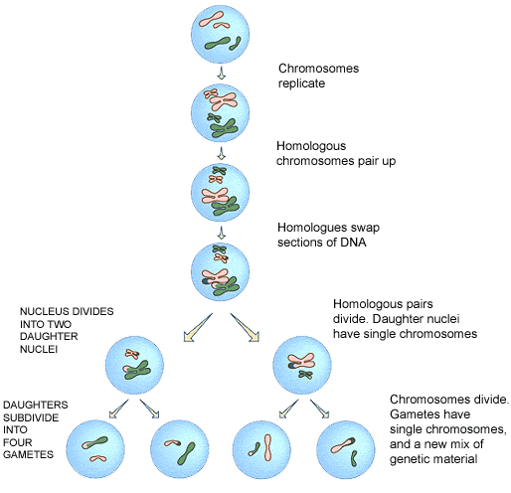

20. Describe the type of adaptation displayed in each image and explain how it helps in the survival of the organism. [6 marks]
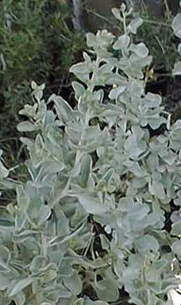
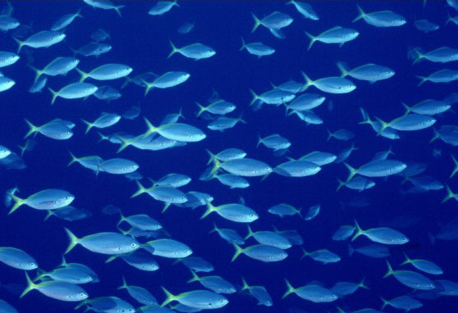
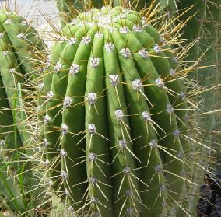

A
B
C

A

B

C

MULTIPLE CHOICE ANSWER SHEET

SUBJECT

SURNAME

OTHER
NAMES

DIRECTIONS:
1. USE A ‘2B’. ‘B’ OR ‘HB’ PENCIL. DO NOT USE A BALLPOINT OR INK PEN.

2. MARK THE BOXES IN THE FOLLOWING WAY [A] [B] [C] [D].

3. PLEASE ENTER YOUR SURNAME OR STUDENT NUMBER IN THE BOXES AS DIRECTED BY YOUR
SUPERVISOR.

4. GIVE ONLY ONE ANSWER FOR EACH QUESTION. IF YOU CHANGE YOUR MIND ERASE YOUR
MARK COMPLETELY AND THEN MARK YOUR NEW ANSWER. MORE THAN ONE ANSWER
WILL INVALIDATE THE ANSWER.

5. YOUR ANSWER SHEET WILL BE COLLECTED SEPARATELY BY THE SUPERVISOR AT THE
END OF THE EXAMINATION.

1 [A] [B] [C] [D]
2 [A] [B] [C] [D]
3 [A] [B] [C] [D]
4 [A] [B] [C] [D]
5 [A] [B] [C] [D]
6 [A] [B] [C] [D]
7 [A] [B] [C] [D]
8 [A] [B] [C] [D]
9 [A] [B] [C] [D]
10 [A] [B] [C] [D]

